“I never would have known my neighbors if it weren’t for the TimeBank because I would not have introduced myself. It gave me a sense of security to know our neighbors’ names. You really want to raise your kids in a neighborhood where you know people.”
TimeBank Member Jeanetta

Live & Silent AUCTION
2nd Annual “Bid to Build our Communities”
Saturday, October 10, 2015

7:00 – 8:30 p.m. Silent auction, refreshments, mix & mingle
9:00-10 p.m. Live auction

Birmingham Unitarian Church, 38651 Woodward Ave., Bloomfield Hills, MI
(North of Quarton Road/Big Beaver)

Light refreshments, entertainment, door prizes, free parking

Thank you for your support! A portion of the proceeds from this fundraiser will directly benefit the local TimeBanks that we serve. Your support is critical to TimeBanking in Michigan. Let’s work together to make our communities strong and wonderful places to live.
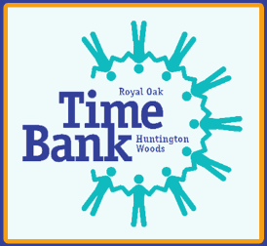

Michigan Alliance of TimeBanks
27580 California Dr. SE
Lathrup Village, MI 48076
248-797-2728 or www.mitimebanks.org for more info

