“I never would have known my neighbors if it weren’t for the TimeBank because I would not have introduced myself. It gave me a sense of security to know our neighbors’ names. You really want to raise your kids in a neighborhood where you know people.”
TimeBank Member Jeanetta

Live & Silent AUCTION
1ST Ever “Bidding to Build our Communities” Auction
Saturday, October 18 from 7:00 - 9:00 p.m.
Royal Oak Woman’s Club, 404 S. Pleasant, Royal Oak
Light refreshments, entertainment, door prizes, free parking

Thank you for your support! A portion of the proceeds from this fundraiser will directly benefit the local TimeBanks that we serve. Your support is critical to TimeBanking in Michigan. Let’s work together to make our communities strong and wonderful places to live.
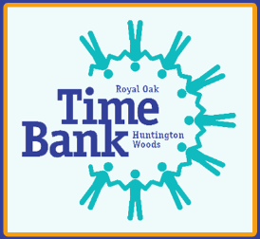
Michigan Alliance of TimeBanks
27580 California Dr. SE
Lathrup Village, MI 48076
www.mitimebanks.org for more info

